**NAAN MUDHALVAN**

**SALESFORCE DEVELOPER**

**PROJECT TITTLE: BUILD AN EVENT MANAGEMENT SYSTEM**

**COLLEGE NAME:MAHENDRA ENGINEERING COLLEGE FOR WOMEN**

**TEAM MEMBER**

**MADHUMITHA R(611420104033)**

**MANJULA DEVI M(611420104036)**

**MEENA R(611420104039 )**

**MUGILA M(611420104043 )**

**COLLEGE SPOC FACULTY MENTOR**

**M.MANIMEGALAI,M.E N.KOWSALYA,M.E**

**PROJECT GOAL:**

He goal of building an event management system is to create a software application or platform that streamlines the planning, organization, and execution of various types of events. The primary objective of an event management system is to make the process of planning and executing events as efficient and stress-free as possible, ensuring a positive experience for both event organizers and attendees. It can save time, reduce manual tasks, and help make events more successful and enjoyable.

**PROJECT DESCRIPTION:**

He project aim is to provide real-time knowledge for all the students who have basicknowledge of Salesforce and Looking for a real-time project. This project will also help those professionals who are in cross-technology and want to switch to Salesforce. With the help of this project they will gain knowledge and can include it into their resume as well. The event management system isa comprehensive software solution designed to facilitate the seamless planning, organization, and execution of events of various scales and types. This system aims to empower event organizers, attendees, and stakeholders with a set of powerful tools that streamline the entire event lifecycle.

**TECHNICAL ARCHITECTURE**

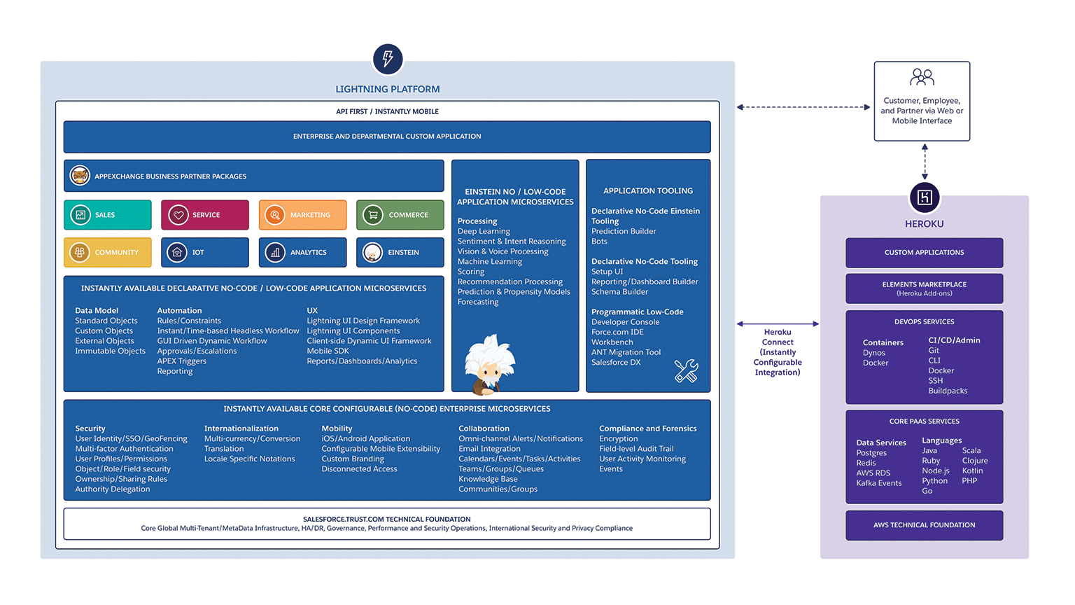

**Salesforce:**

**Creating A Salesforce Developer Org**







**OBJECT:**

Creation of Attendees Object:

1.click on the gear icon and then select Setup.

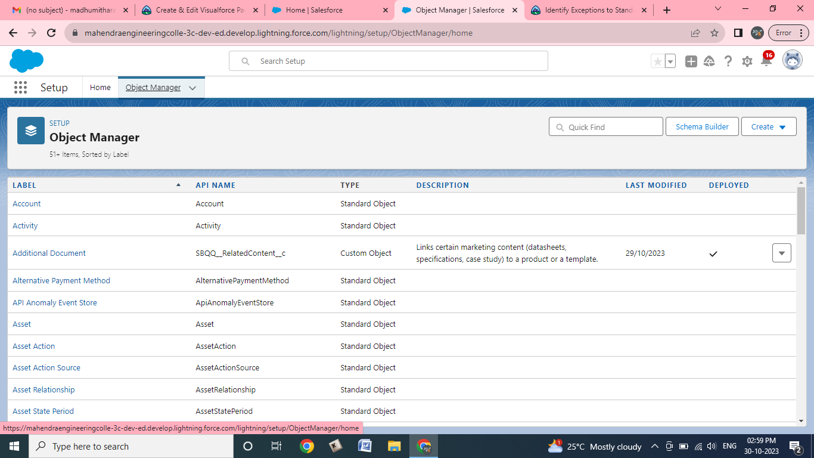

**2.Click on the object manager tab just beside the home tap**

**3.After the above step,have a look on the extreme right you will find a create Dropdown click on that and select Custom Object.**

**a.create the object**

**b.Label:Attendee**

**c.Plural label:Attendees**

**d.Record name:Attendee Name**

**e.check the allow Reports**

**f.check the Allow Search checkbox**

**g.click save**

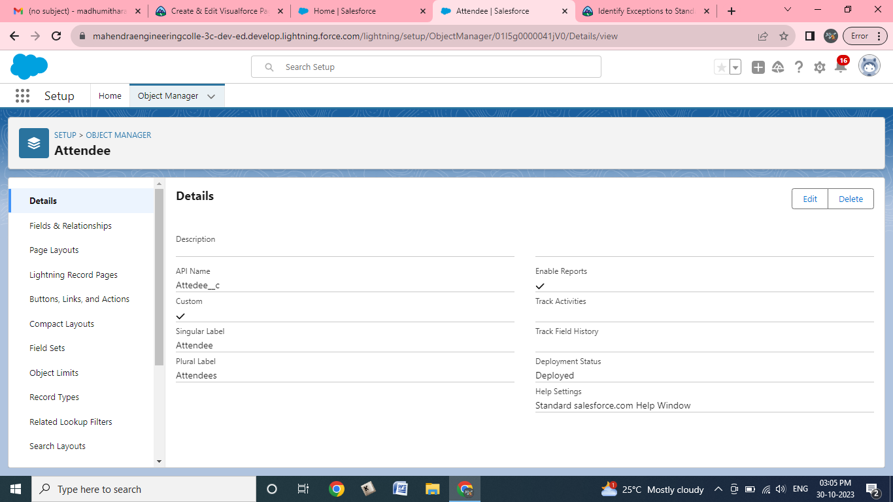

**DASHBOARD**

CREATE A DASHBOARD

1. Click the Dashboards tab.   
   2. Click New Dashboard.

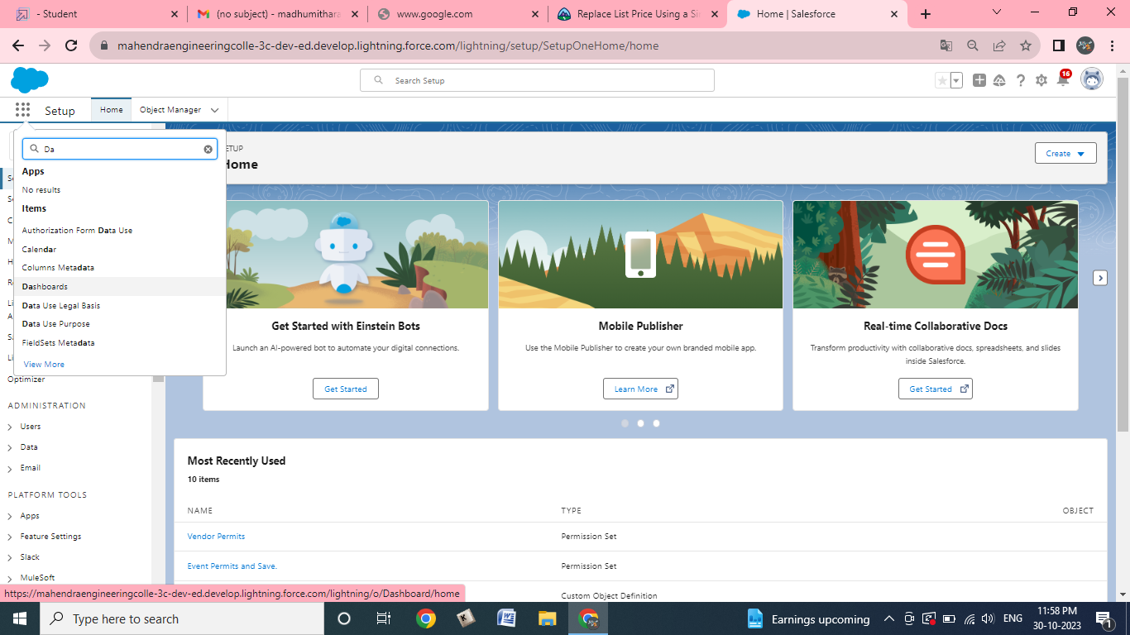

1. Name the dashboard Occasions with Attendees and click Create.   
   4. Click +Component.

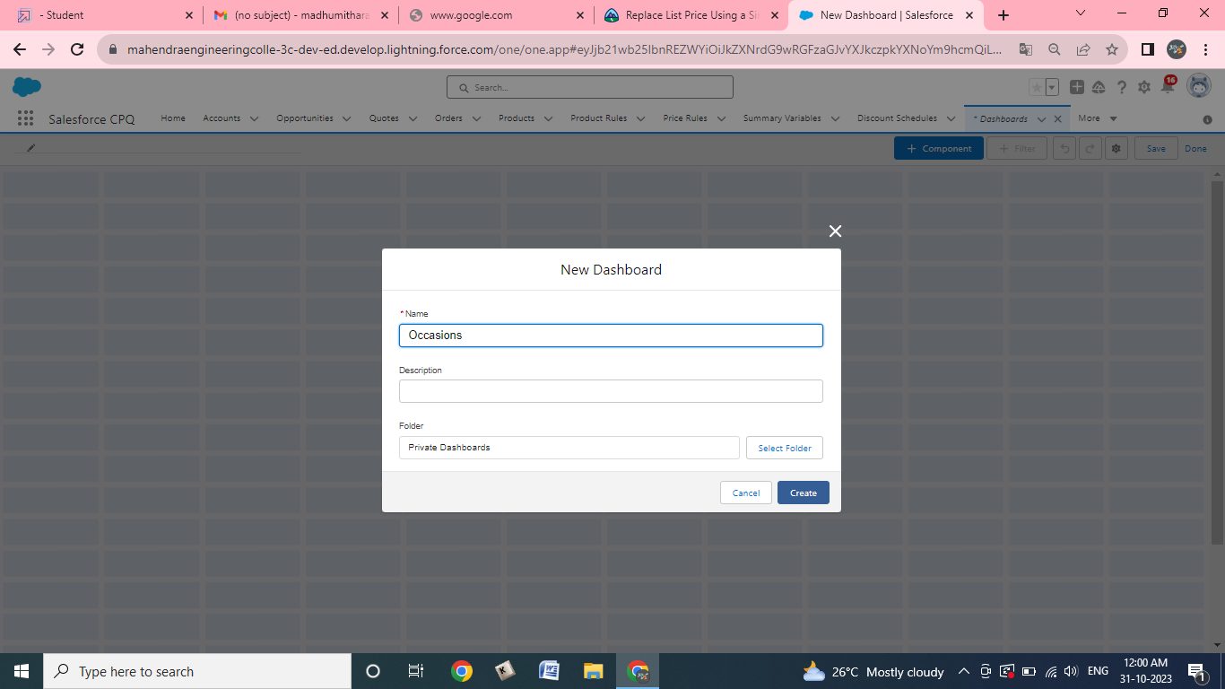

5. Select Occasions with Attendees and click Select.   
6. Select the Vertical Bar Chart component and click Add.

7. Click Save and then Done.

**Permission Sets**

**Creating A Permission Set**

From setup search “permission sets” in quick find and select **permission set** then click on **New**

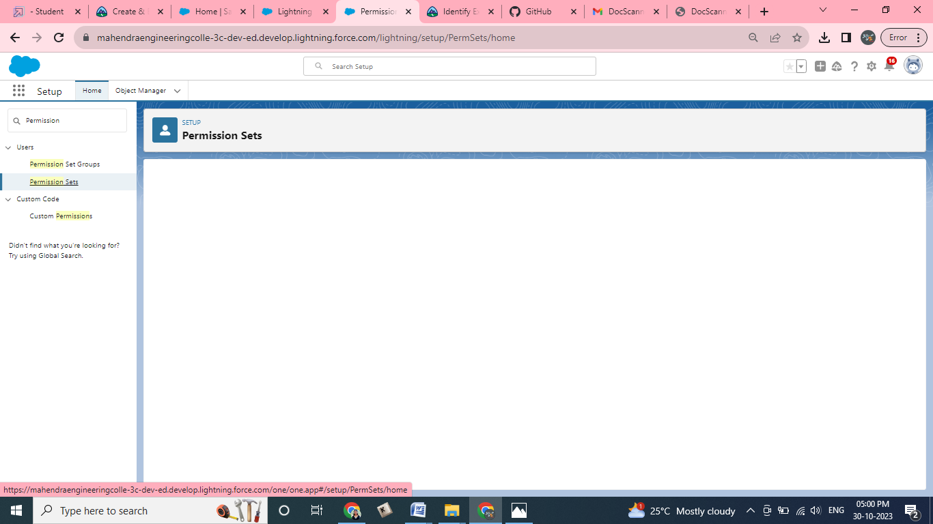

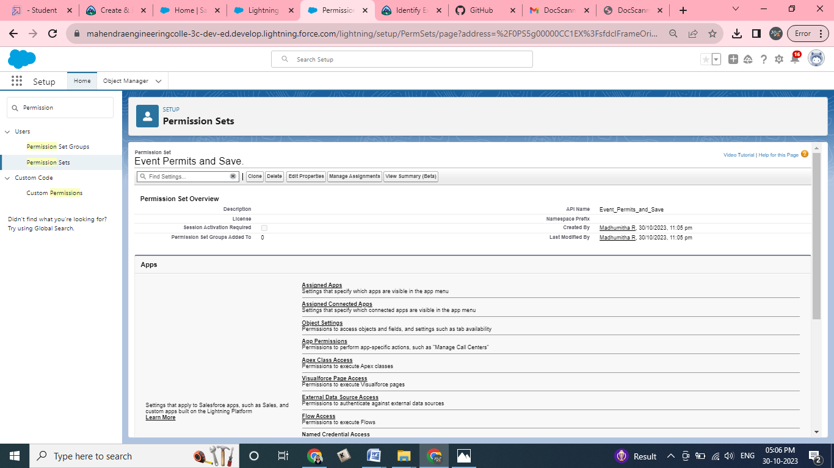

* Enter label as: Event Permits and Save.
* After saving the permission click on the Manage assignment
* Now click on the Add Assignment

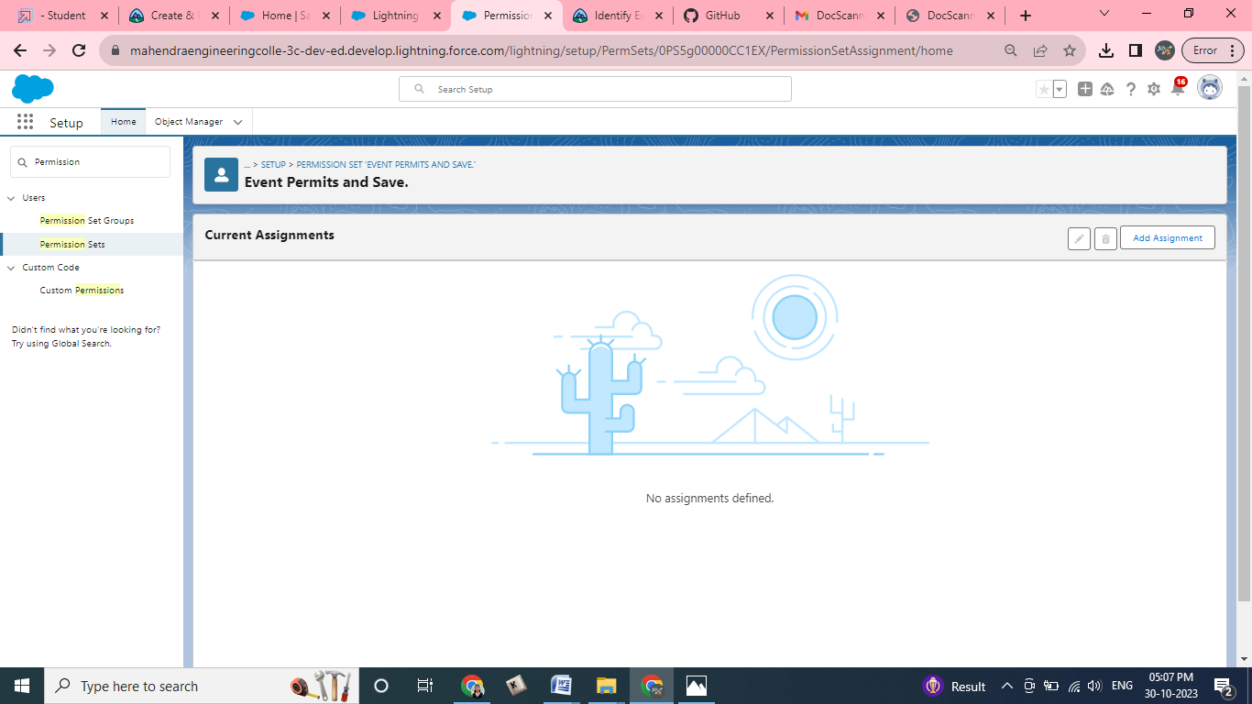

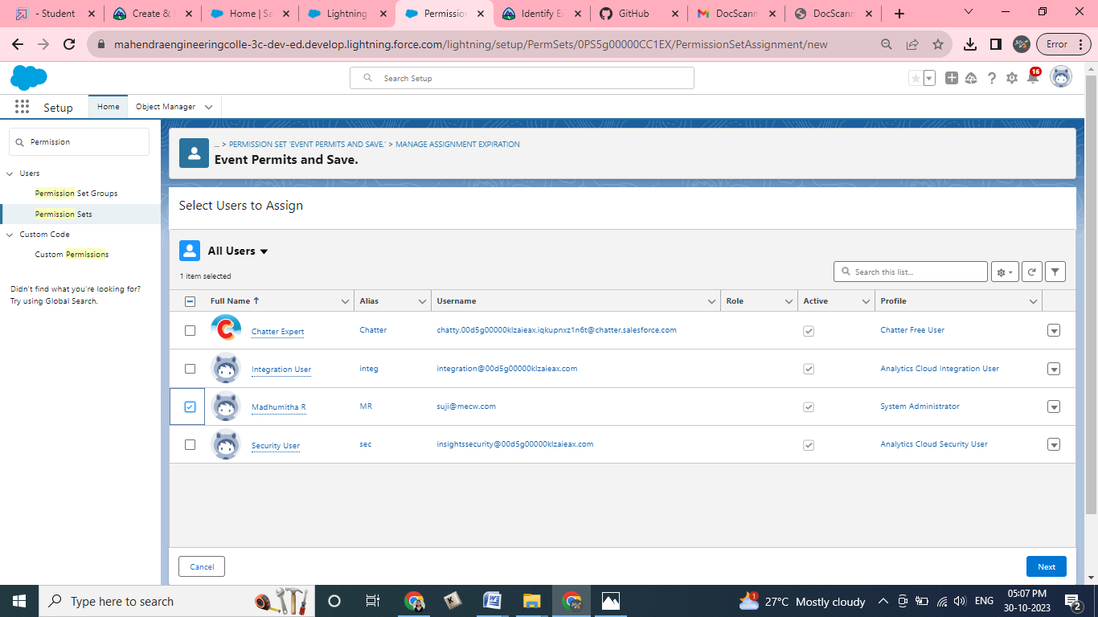

* Now select the users which you create and click on next Assign ,Done

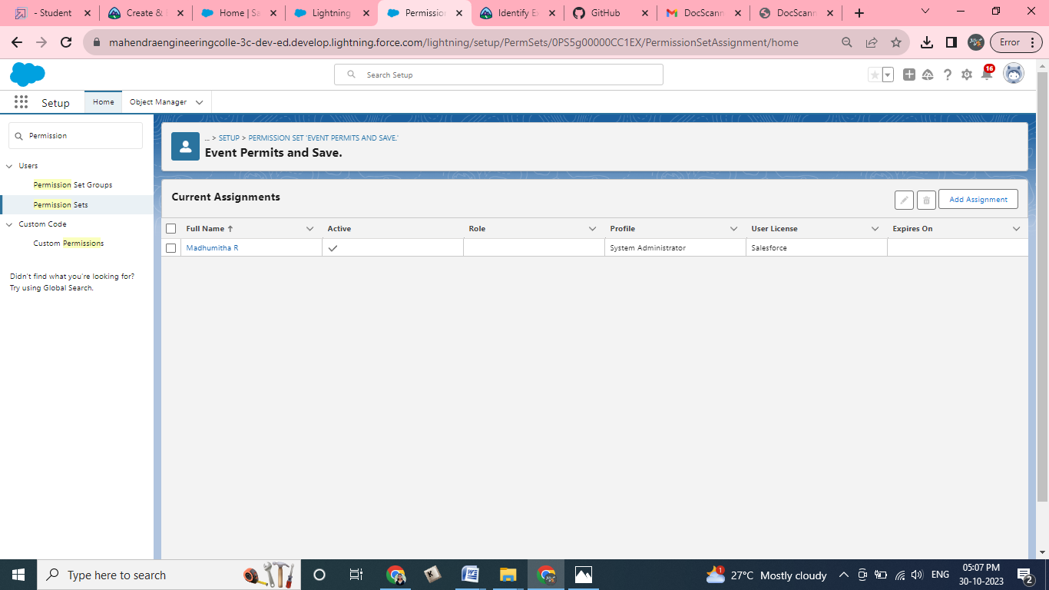

### User Adoption

### Delete A Record(Occasion)

1. Click on App Launcher on left side of screen.
2. Search Event Management & click on it.
3. Click on Occasion Tab.

### Screenshot (7).png

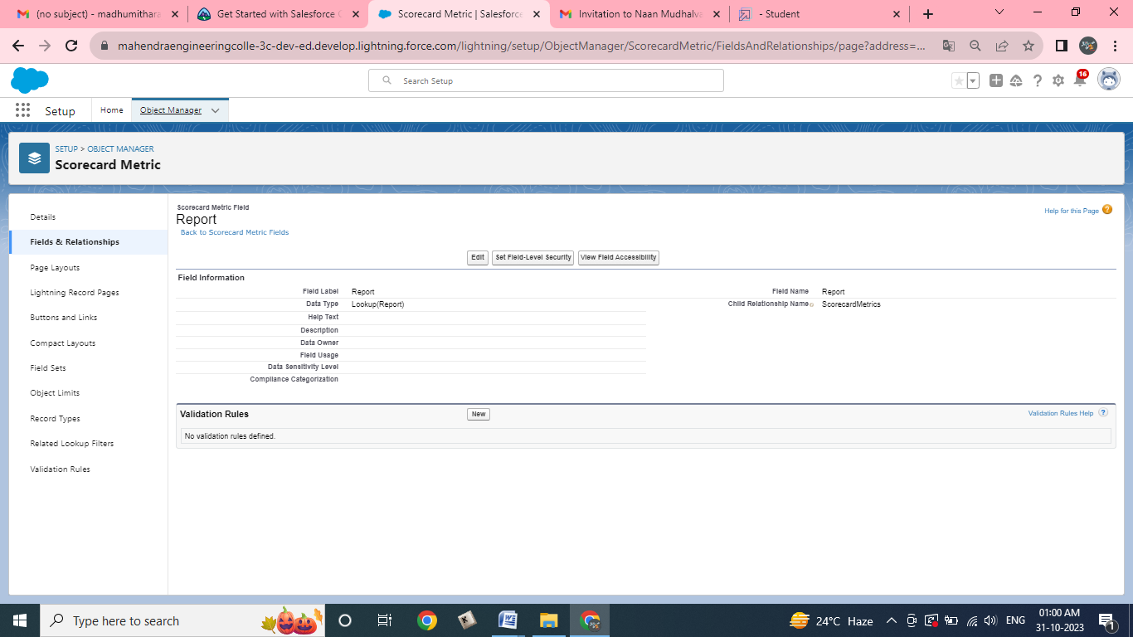

1. Click on Arrow at right hand side on that Particular record.
2. Click delete and delete again.

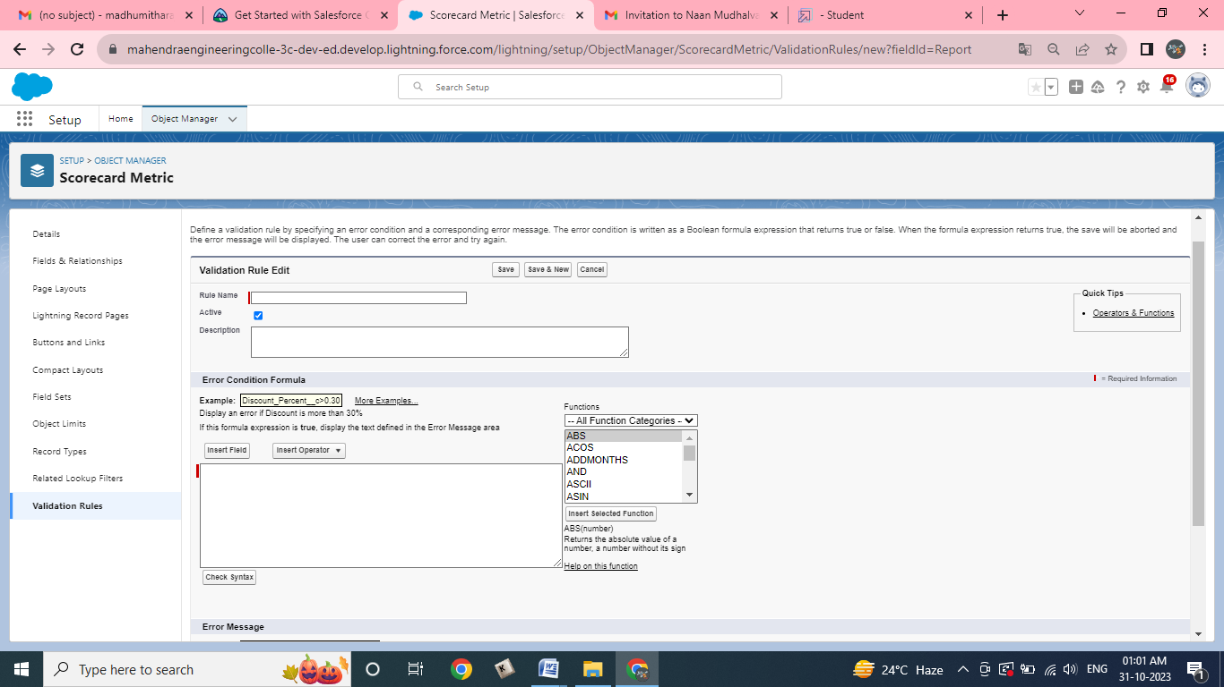

**Profile**

### Create A Profile

### From Setup enter Profiles in the Quick Find box, and select Profiles.  2. From the list of profiles, find Standard User.  3. Click Clone.

### Screenshot (14).png

### Screenshot (16).png

4. For Profile Name, enter Event vendors profile.   
5. Click **Save**.

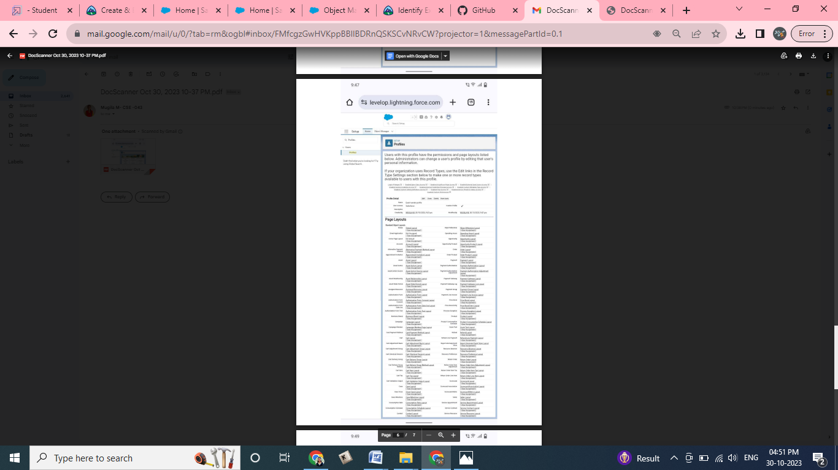

6. While still on the Event profile page, then click **Edit**.

7. Scroll down to Custom Object Permissions and Give view all access permissions to the Attendees, speakers and vendors.   
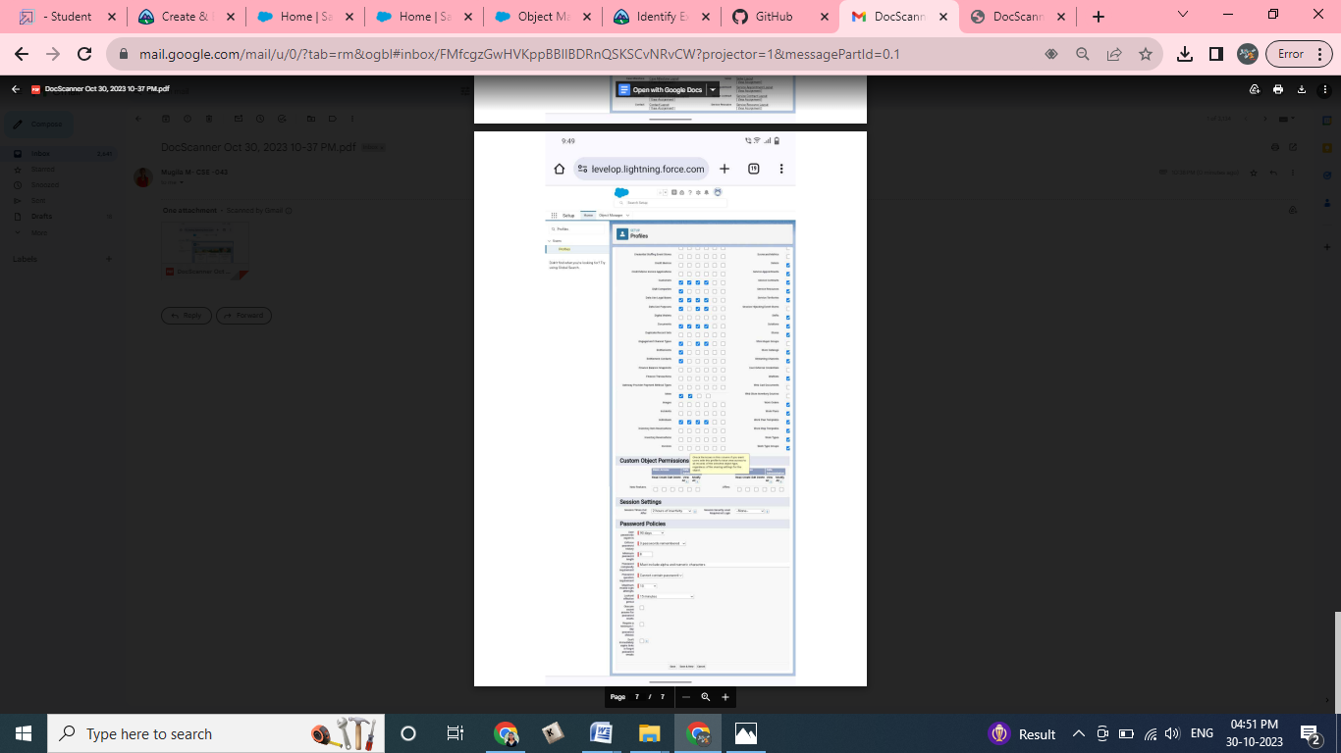

### User

### Create A User

Create a user with a username as “Rahul Sharma”, and assign him the sales executive profile. From setup type “users” in quick find and select users, then click **New User**

* First Name: Rahul
* Last Name: Sharma
* Alias: Rahus
* Email: provide your personal email id for future reference
* Username: rahulsharma@thesmartbridge.com
* Nickname: Rahu
* Role: leave it as default
* User License: Salesforce Platform
* Profile: Event vendors profile

### Screenshot (45).png

### View Report And Dashboard

### View Dashboard

Click on App Launcher on left side of screen.

Search Event management & click on it.

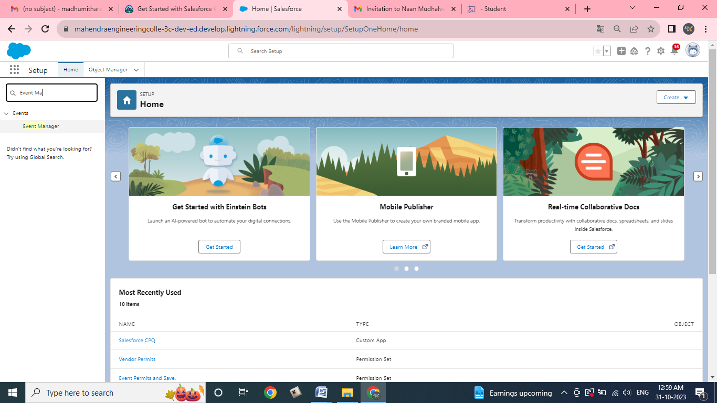

Click on Dashboard Tab.

Click on Occasions with Attendees & see records



